**“WEB WARDEN”**

Submitted in partial fulfillment of the requirements

of the degree of

Bachelor of Engineering

*By:*

**PRAVIN ANILKUMAR 05**

**SHREYA SAKPAL 07**

**HITANSHU SHAH 10**

*Supervisor:*

**Prof. ODILIA GONSALVES**



Department of Information Technology

Atharva College of Engineering

Year: 2019-20



**ATHARVA COLLEGE OF ENGINEERING**

**MALAD (W), MUMBAI 400 095**

**YEAR: 2019-2020**

**CERTIFICATE**

*This is to certify that*

**PRAVIN ANILKUMAR**

**SHREYA SAKPAL**

**HITANSHU SHAH**

*have submitted the Mini Project report for the requirements of the Bachelor of Engineering in Information Technology satisfactorily*

on

**“WEB WARDEN”**

*As prescribed by the* ***University of Mumbai*** *Under the guidance of*

**PROJECT GUIDE H.O.D. EXTERNAL EXAMINER**

**PROF.ODILIA GONSALVES COLLEGE SEAL**

**APPROVAL FOR T. E. MINI PROJECT REPORT**

This project report entitled **“WEB WARDEN”** by PRAVIN ANILKUMAR, SHREYA SAKPAL and HITANSHU SHAH is approved for the degree of ***Bachelor of Engineering in Information Technology***

Mini Project Guide: ----------------------------------

Date:

Place:**DECLARATION**

We declare that this written submission represents our ideas in our own words and where others' ideas or words have been included, we have adequately cited and referenced the original sources. We also declare that We have adhered to all principles of academic honesty and integrity and have not misrepresented or fabricated or falsified any idea/data/fact/source in my submission. We understand that any violation of the above will be cause for disciplinary action by the Institute and can also evoke penal action from the sources which have thus not been properly cited or from whom proper permission has not been taken when needed.

-----------------------------------------

PRAVIN ANILUMAR-05

-----------------------------------------

SHREYA SAKPAL -07

-----------------------------------------

HITANSHU SHAH -10

Date:

**ABSTRACT**

Recording attendance in classroom with strength of 70-80 students using traditional manual methods becomes a bickering task. Our system “WEB WARDEN” reduces the hassle for the teachers and helps them carry out the task in order. Through this project we aim to reduce the hassle of manual attendance taking methods and provide a easy solution to record attendance, view attendance and create a defaulters list for the same. Through this website students can also view their attendance and see in which subject they lack attendance. Students can also view notes uploaded by the teacher on this website. Due to this the student need not view various different sites to view the study material rather they can find everything at a single place. Thus the name “WEB WARDEN”. WEB WARDEN as the name suggests will truly act as a warden to keep a watch on the students and help them with their academics. This platform acts as a bridge between teachers and students to be informed about the activities happening inside the classroom.

**TABLE OF CONTENTS**

|  |  |  |
| --- | --- | --- |
| **CHAPTER NO.** | **TOPIC** | **PG NO.** |
| **1** | **INTODUCTION TO WEB-WARDEN** | **08** |
| 1.1 | NEED | 08 |
| 1.2 | PROBLEM STATEMENT | 08 |
| 1.3 | AIM AND OBJECTIVES | 08 |
| 1.4 | APPLICATION AND SCOPE | 09 |
| **2** | **HARDWARE AND SOFTWARE USED** | **10** |
| 2.1 | HARDWARE REQUIRMENTS | 10 |
| 2.2 | SOFTWARE REQUIRMENTS | 10 |
| **3** | **CODE IMPLEMENTATION** | **11** |
| 3.1 | HTML CODE | 11 |
| 3.2 | PHP CODE | 15 |
| 3.3 | CSS CODE | 18 |
| 3.4 | JAVASCRIPT CODE | 21 |
| **4** | **WEBSITE SNAPS** | **22** |
| **5** | **CONCLUSION** | **25** |
|  | **REFERENCES** | **25** |

**LIST OF FIGURES**

|  |  |  |
| --- | --- | --- |
| **LIST OF FIGURES** | **TOPIC** | **PG.NO** |
| 1 | HOME PAGE | 22 |
| 2 | MAIN PAGE | 22 |
| 3 | TEACHERS PAGE | 23 |
| 4 | ATTENDANCE PAGE | 23 |
| 5 | MARK ATTENDANCE PAGE | 24 |
| 6 | STUDENT PAGE | 24 |

**CHAPTER 1:**

**INTRODUCTION TO WEB WARDEN**

* 1. **NEED**

Recording attendance is bickering task in classroom full of students and to record attendance, a lot precious lecture time is wasted .Through this project we aim to reduce the hassle of manual attendance taking methods and provide a easy solution to record attendance, view attendance and create a defaulters list for the same.

* 1. **PROBLEM STATEMENT**

Recording attendance in classroom with a strength of 70-80 students using traditional manual methods becomes a bickering task. Our system “WEB WARDEN” reduces the hassle for the teachers and helps them carry out the task in order.

* 1. **AIM AND OBJECTIVES**

AIM:

To record attendance as it offers one to maintain his/her track record in classrooms also one can view syllabus and study materials posted all in one place.

OBJECTIVES:

* To provide teacher a uniform platform where they can maintain all their records of attendance till date.
* To minimize the efforts put in by teachers to create defaulters list.
* To provide a platform where students can gain access to all the study materials and attendance at a single platform**.**
  1. **APPLICATION AND SCOPE**

APPLICATION:

* Can be implemented as a student teacher forum in colleges, schools and universities.
* Can be used as a attendance tracker for colleges and universities.

SCOPE:

* Hassle free alternative to traditional methods of recording attendance.
* Teachers can post their notes for the respective lectures.
* Students need not browse different web pages for study materials as they are available at a single place.
* Students can keep track of their attendance and cover up at places where they lack.

**CHAPTER 2:**

**HARDWARE AND SOFTWARE USED**

**2.1 HARDWARE REQUIREMENTS**

* Windows XP minimum.
* RAM 128 MB (or) higher
* Hard disk 10GB

**2.2 SOFTWARE REQUIRMENTS**

* Tools : Sublime Text
* Operating System : Windows 10
* Server side : PHP-MyAdmin, WAMP
* Client Site : HTML 5, JavaScript, CSS
* Services : Localhost
* Database : MySQL

**CHAPTER 3:**

**CODING IMPLEMENTATION**

**3.1 HTML CODE**

(HOME1 PAGE)

<!Doctype html>

<html lang="en">

<meta charset="UTF-8">

<link rel="stylesheet" href="css/home1.css">

<head>

<title>home1</title>

<meta name="viewport" content="width=device-width, initial-scale=1">

</head>

<style type="text/css">

body {

background-image: url("bac.jpg");

background-attachment: scroll;

background-size: cover;

background-repeat: no-repeat;

min-height: 100%;

overflow-y: auto;

}

</style>

<body>

<a>HOME</a>

<a>ABOUT</a>

<a>HELP</a>

<a>LOGIN/SIGN UP</a>

<a>MOOC Courses</a>

<a>Syllabus</a>

<br>

<h1> Your class is only a click away... </h1>

<a href="slogin.html"><button class="button button1">Login as Student</button></a>

<a href="tlogin.html"><button class="button button1">Login as Teacher</button></a>

<a href="signup.html"><button class="button button1">Sign Up</button></a>

</body>

</html>

(ATTENDANCE PAGE)

<!Doctype html>

<html lang="en">

<meta charset="UTF-8">

<head>

<title>SignUp</title>

<link rel="stylesheet" href="css/tt.css">

</head>

<style type="text/css">

p{

font-family: Comic Sans MS,cursive,sans-serif;

font-size: 30px;

color: white;

text-align: center;

}

</style>

<body class="signup">

<span class="topnav">

<a>HOME</a> &nbsp; &nbsp; &nbsp;

<a>ABOUT</a> &nbsp; &nbsp; &nbsp;

<a>HELP</a> &nbsp; &nbsp; &nbsp;

<a>CREATE SUBJECT</a> &nbsp; &nbsp; &nbsp;

<a>POST</a> &nbsp; &nbsp; &nbsp;

<a>ATTENDANCE</a> &nbsp; &nbsp; &nbsp;

<a>MOOC Courses</a>&nbsp; &nbsp; &nbsp;

<a>Syllabus</a> &nbsp; &nbsp; &nbsp;

<a>TIMETABLE</a> &nbsp; &nbsp; &nbsp;

</span>

<br>

<br>

<br>

<p>

Select-Subject:

<br>

<br>

<br>

<a href="ip.php"><button class="bt">IP</button></a>

<a href="admt.php"><button class="bt">ADMT</button></a>

<a href="adsa.php"><button class="bt">ADSA</button></a>

<a href="mep.php"><button class="bt">MEP</button></a>

<a href="cns.php"><button class="bt">CNS</button></a>

<a href="bce.php"><button class="bt">BCE</button></a>

<br>

<br>

<a href=""><button class="bt">OVERALL ATTENDANCE</button></a>

</p>

</body>

</html>

(MOOC COURSE)

<!DOCTYPE html>

<html lang="en">

<head>

<meta charset="UTF-8">

<title>onlinecourses</title>

<link rel="stylesheet" href="css/mooc.css">

</head>

<body id="onlinecourses">

<div class="container">

<header class="header">

<a class="link-title" lhref="/">NEXGEN EDUCATION</a>

</header>

<span class="topnav">

<a href="home.html">HOME</a> &nbsp; &nbsp; &nbsp;

<a href="aboutus.html">ABOUT</a> &nbsp; &nbsp; &nbsp;

<a href="help.html">HELP</a> &nbsp; &nbsp; &nbsp;

<a href="">CREATE SUBJECT</a> &nbsp; &nbsp; &nbsp;

<a>POST</a> &nbsp; &nbsp; &nbsp;

<a>ATTENDANCE</a> &nbsp; &nbsp; &nbsp;

</span>

<article class="main">

<h1 class="page-heading"></h1>

<div id="form">

<h2>

MOOC Courses

</h2>

<br>

<h1>

Complete certified Courses and develop your skills!

</h1>

<p>

<a href="https://www.saylor.org/"><button class="bt">Saylor Academy</button></a>

</p>

<p>

<a href="https://www.udemy.com"><button class="bt">Udemy</button></a>

</p>

<p>

<a href="https://www.edx.org/"><button class="bt">Edx</button></a>

</p>

<p>

<a href="https://in.udacity.com/"><button class="bt">Udacity</button></a>

</p>

<p>

<a href="https://alison.com/en"><button class="bt">Alison</button></a>

</p>

<p>

<a href="Home.html"><button class="bt">Back</button></a>

</p>

</form>

</div>

</article>

<footer>

&copy; NEXGEN EDUCATION &nbsp; <span class="seperator">||

</footer>

</div>

</body>

</html>

**3.2 PHP CODE**

(SIGN UP)

<?php

$fname = $_POST['fname'];

$lname = $_POST['lname'];

$username = $_POST['username'];

$m_no = $_POST['m_no'];

$e_mail = $_POST['e_mail'];

$college = $_POST['college'];

$gender = $_POST['gender'];

$prof = $_POST['prof'];

$password = $_POST['password'];

$r_no = $_POST['r_no'];

$class = $_POST['class'];

$branch = $_POST['branch'];

if (!empty($fname)|| !empty($lname) || !empty($username) ||!empty($m_no) || !empty($e_mail) || !empty($college) ||!empty($gender) ||!empty($prof) ||!empty($password) || !empty($r_no)|| !empty($class)|| !empty($branch) ) {

$host = "localhost";

$dbUsername = "root";

$dbPassword = "";

$dbname = "webwarden";

//create connection

$conn = new mysqli($host, $dbUsername, $dbPassword, $dbname);

if (mysqli_connect_error()) {

die('Connect Error('. mysqli_connect_errno().')'. mysqli_connect_error());

} else {

$SELECT = "SELECT e_mail FROM users WHERE e_mail = ? LIMIT 1";

$INSERT = "INSERT INTO users (fname, lname, username, m_no, e_mail, college, gender, prof, password, branch, r_no, class) values(?, ?, ?, ?, ?, ?, ?, ?, ?, ?, ?, ?)";

//Prepare statement

$stmt = $conn->prepare($SELECT);

$stmt->bind_param("s", $e_mail);

$stmt->execute();

$stmt->bind_result($e_mail);

$stmt->store_result();

$rnum = $stmt->num_rows;

if ($rnum==0) {

$stmt->close();

$stmt = $conn->prepare($INSERT);

$stmt->bind_param("ssssssssssss", $fname, $lname, $username, $m_no, $e_mail, $college, $gender, $prof, $password, $r_no, $class, $branch);

$stmt->execute();

echo "Registered sucessfully";

} else {

echo "Someone already register using this email";

}

$stmt->close();

$conn->close();

}

} else {

echo "All fields are required";

die();

}

?>

(LOGIN)

<?php

$e_mail = $_POST['e_mail'];

$password = $_POST['password'];

$host = "localhost";

$dbUsername = "root";

$dbPassword = "";

$dbname = "webwarden";

//create connection

$conn = new mysqli($host, $dbUsername, $dbPassword, $dbname);

$e_mail = stripcslashes($e_mail);

$password = stripcslashes($password);

$e_mail = mysqli_real_escape_string($conn, $_POST['e_mail']);

$password = mysqli_real_escape_string($conn, $_POST['password']);

$result = mysqli_query($conn,"select e_mail,password from users where e_mail = '$e_mail' && password='$password' && prof='student'")

or die("failed to query database");

$row = mysqli_fetch_array($result);

if ($row['e_mail'] == $e_mail && $row['password'] == $password ){

echo "Succesfully logged in Welcome " ;

header("location: student.php");

} else {

echo "Make sure you are a student!

Incorrect password or email

Failed to login";

}

?>

**3.3 CSS CODE**

(HOME)

#home1 {

background-color: lightcyan;

text-align: center;

font-family: Comic Sans MS,cursive,sans-serif;

color: darkcyan;

}

.center {

display: block;

margin-left: auto;

margin-right: auto;

width: auto;

height: auto;

}

.button {

background-color: #4CAF50; /* Green */

border: none;

color: white;

padding: 6px 18px;

text-align: center;

text-decoration: none;

display: inline-block;

font-size: 30px;

margin: 4px 2px;

cursor: pointer;

-webkit-transition-duration: 0.4s; /* Safari */

transition-duration: 0.4s;

border-radius: 12px;

font-family: Comic Sans MS,cursive,sans-serif;

color: darkcyan;

}

.button1 {

background-color: #AFEEEE;

color: black;

border: 2px solid #3b7687;

border-radius: 12px;

color: darkcyan;

}

.button1:hover {

background-color: #3b7687;

box-shadow: 0 12px 16px 0 rgba(0,0,0,0.24),0 17px 50px 0 rgba(0,0,0,0.19);

border-radius: 12px;

color: aqua;

}

(MOOC)

.topnav {

font-size: 25px;

font-family: Comic Sans MS,cursive,sans-serif;

font-weight: bolder;

}

.topnav a {

float: left;

color: #f2f2f2;

text-align: center;

padding: 14px 16px;

text-decoration: none;

}

.topnav a:hover {

background-color: lightcyan;

color: darkcyan;

}

h1,h2{

font-size: 30px;

font-family: Comic Sans MS,cursive,sans-serif;

font-weight: bolder;

text-align: center;

color: white;

}

body{

background-image: url("mc.jpg");

background-attachment: scroll;

background-size: cover;

background-repeat: no-repeat;

min-height: 100%;

overflow-y: auto;

}

.bt{

background-color: #4CAF50; /* Green */

border: none;

color: white;

text-align: center;

text-decoration: none;

display: inline-block;

font-size: 40px;

cursor: pointer;

-webkit-transition-duration: 0.4s; /* Safari */

transition-duration: 0.4s; border-radius: 12px;

font-family: Comic Sans MS,cursive,sans-serif;

color: darkcyan; background-color: #AFEEEE;

color: black;

border: 2px solid #3b7687;

border-radius: 12px;

color: darkcyan;

align-self: center;

alignment-baseline: central;

padding-left: auto;

margin-left: auto;}

.bt:hover { background-color: #3b7687;

box-shadow: 0 12px 16px 0 rgba(0,0,0,0.24),0 17px 50px 0 rgba(0,0,0,0.19);

border-radius: 12px; color: aqua;}

**3.4 JAVASCRIPT CODE**

(TO ADD A WELCOME MESSAGE)

<script language="javascript" type="text/javascript">

alert("Welcome")</script>

(TO PRINT DEFAULTERS LIST)

<SCRIPT LANGUAGE="JavaScript">

if (window.print) {

document.write('<form> '

+ '<input type=button class="button2 button3" name=print value="Print defaulter List" '

+ 'onClick="javascript:window.print()"> </form>');}</script>

**CHAPTER 4 :**

**WEBSITE SNAPS**

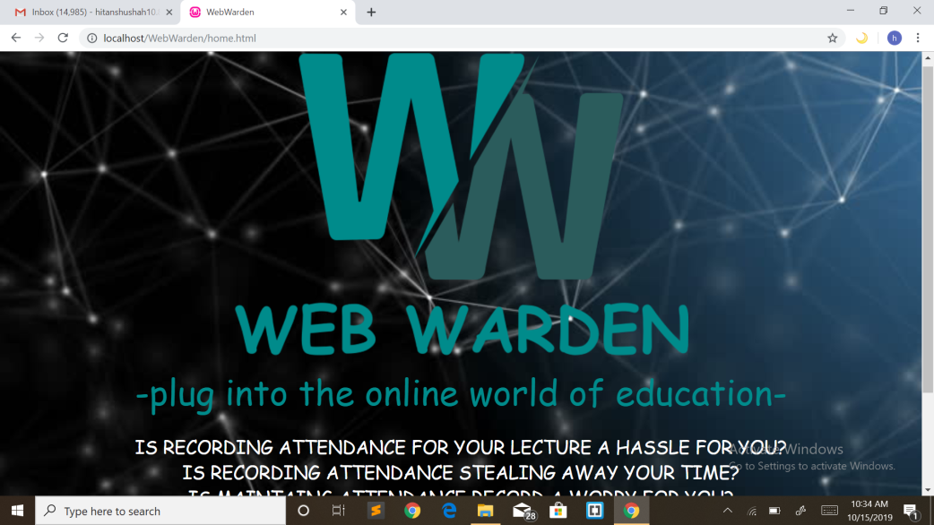

***(fig 1)* HOME PAGE**

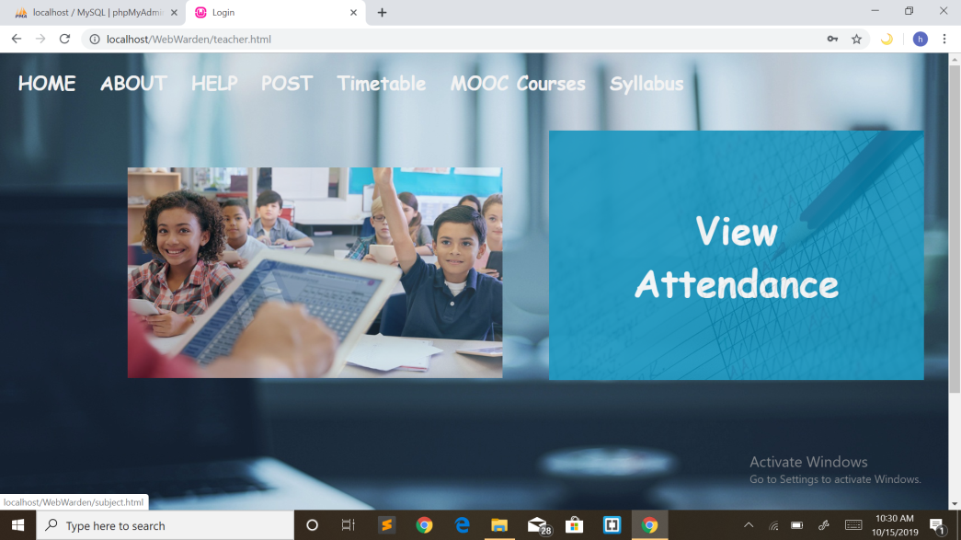

***(fig 2 )*MAIN PAGE**



***(fig 3)* TEACHERS PAGE**

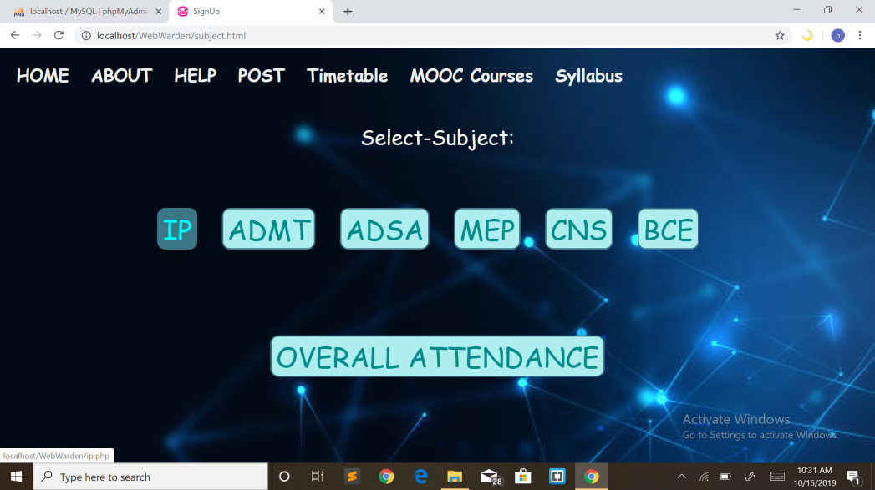

***(fig 4)* ATTENDANCE PAGE**

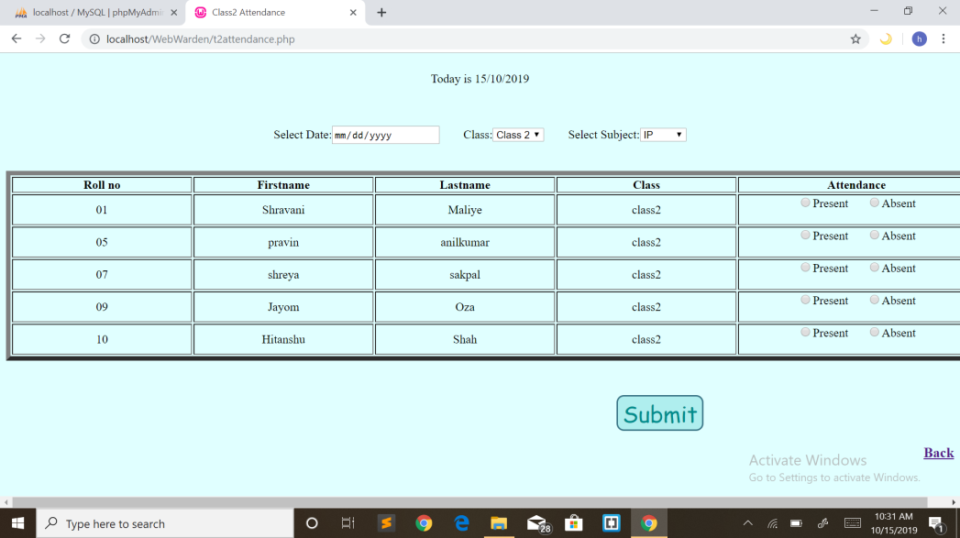

***(fig 5)* MARK ATTENDANCE PAGE**

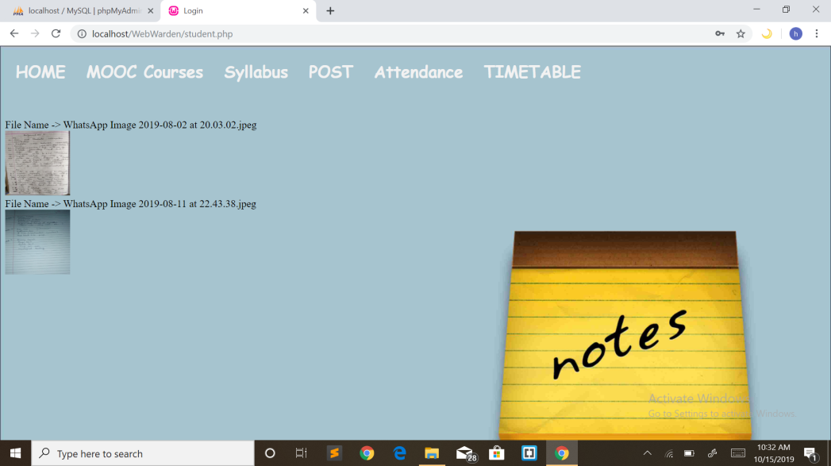

***(fig 6)* STUDENTS PAGE**

**CHAPTER 5:**

**CONCLUSION**

Teacher can invest more time in teaching in a class filled with students, as they can easily record attendance using our system “WEB WARDEN” when compared to traditional manual methods. On the other hand students can easily keep track of their attendance along with fetching study materials all at a single place.

**REFERENCES**

*BOOKS*

[1] Matthew MacDonald, "Creating a Website - The Missing Manual", 3rd ed, 2011, O’Reilly

[2] David Sawyer McFarland, "CSS 3 - The Missing Manual", 3rd ed, 2013, O’Reilly.

*WEBSITES*

[3] https://stackoverflow.com

[4] https://www.sitepoint.com

[5]https://wwwigithub.com